Overview:
Thank you for helping to spread the word about Metro’s Summer 2026 major construction projects. Please feel free to use or adapt the sample material below.
Web pages:
Wmata.com/majorconstruction
Wmata.com/summer2026
Hashtags:
#wmata #YourMetro #metrorail
Sample e-Newsletter copy:
Upcoming Service Changes: Major Construction on the Red Line, July 6-Sept. 7, 2026
Starting July 6, 2026, Metro will close select stations on the Red Line for nine weeks of construction projects to improve tracks and signaling and enhance your ride.
Key Details:
Metro is doing this work to improve the customer experience via the following:
- MTA Purple Line integration at Bethesda station
  - A second mezzanine will be constructed to connect Metro’s Bethesda station on the Red Line to MTA’s Purple Line.
- Reinvestment and rehabilitation
  - Rehabilitation of the platform at Grosvenor-Strathmore to include slab edge replacement, tile replacement, new lighting, and modified drainage.
  - Aerial structure (raised railway route to allow bypassing of a road) infrastructure replacement between Grosvenor-Strathmore and Medical Center.
During the closure, free shuttle buses will replace train service at the impacted stations. The timing of this work is intended to minimize disruption by taking advantage of typically lower ridership during the summer months. This extended closure reduces the need for future weekend shutdowns.
Stay informed and plan your trips accordingly.
Social media channels to follow:
- X: @wmata, @metrorailinfo, @metrobusinfo
- Facebook: Metro Forward
- Instagram: Metro Forward

Sample Social Media Posts
X/Twitter:
Red Line customers: Major Red Line construction will impact Bethesda, Medical Center, and Grosvenor-Strathmore stations from July 6-Sept. 7. Free shuttles will replace trains. Get the details: wmata.com/summer2026 #wmata
Instagram/Facebook:
Red Line customers: Starting July 6, trains will not run between North Bethesda and Friendship Heights for major construction work at Grosvenor-Strathmore, Medical Center, and Bethesda stations through Sept. 7. This project will install a new mezzanine at Bethesda to connect Metro to the @mtamaryland Bethesda Purple Line station and invest in infrastructure at Grosvenor-Strathmore and Medical Center.
Free shuttle buses will replace trains during work, and closed stations will reopen on Sept. 8. Plan ahead and check wmata.com/summer2026 for all the details, including shuttle bus information and travel alternatives. #wmata #YourMetro

Graphics (system & shuttle bus maps)
System Map
English
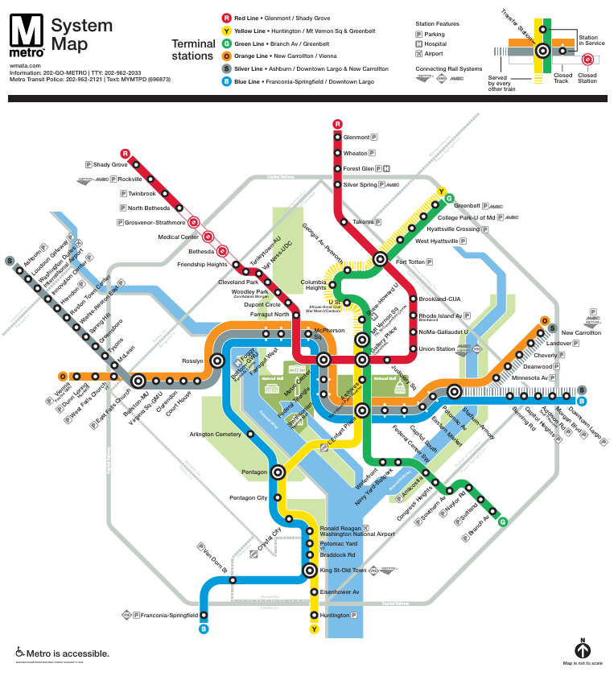

Spanish
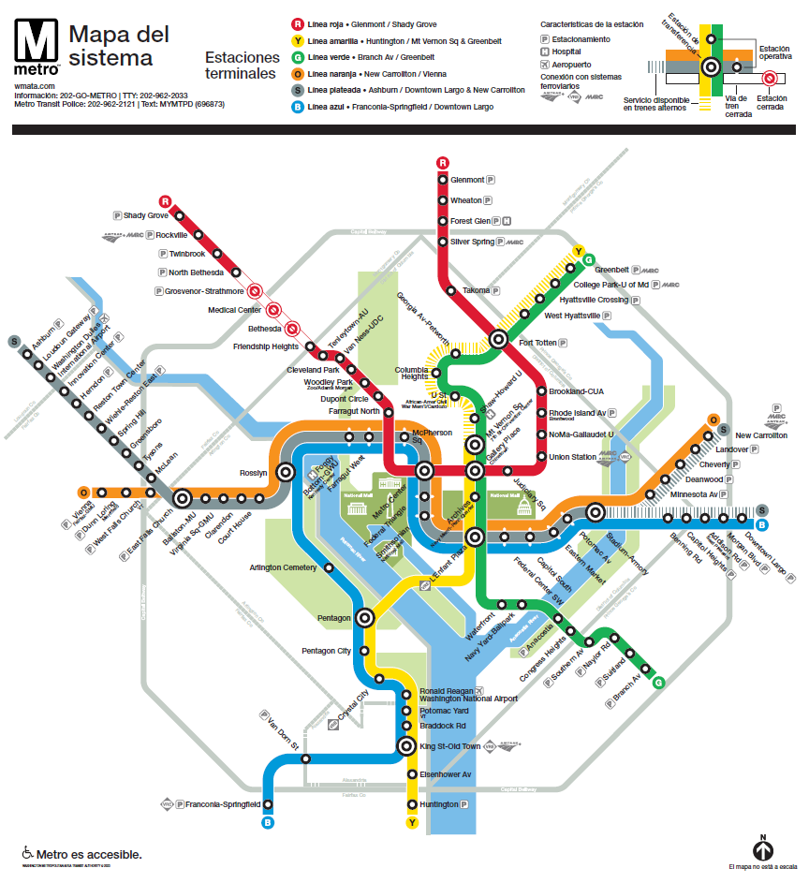

Shuttle bus map
English
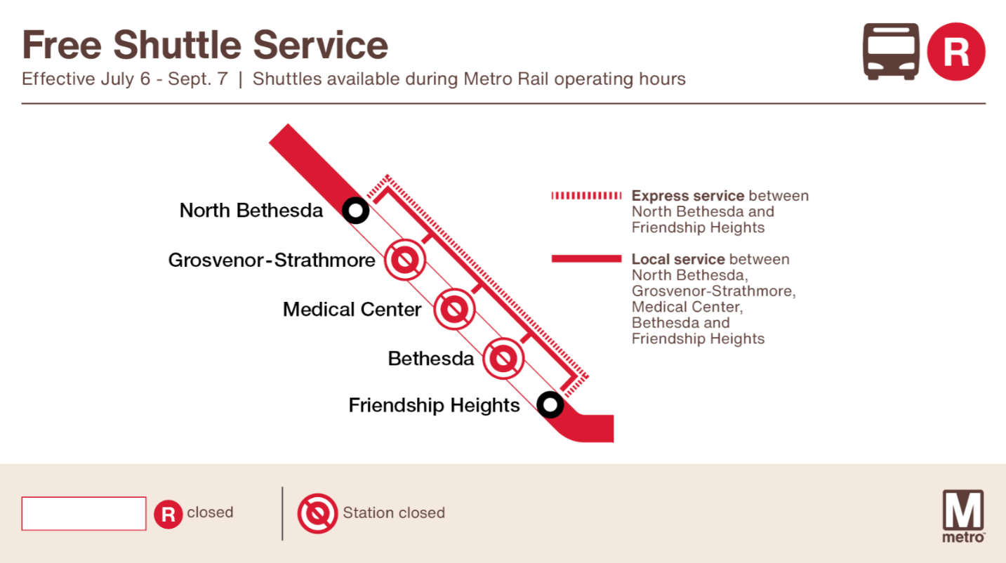
Spanish
