**Overview:**

Thank you for helping get the word out about Metro’s December 2024 major maintenance projects. Please feel free to use or adapt the sample material below.

**Web page:**

[Wmata.com/majorconstruction](http://www.wmata.com/majorconstruction)

**Hashtags:**

#wmata #YourMetro #metrorail

**Sample e-Newsletter copy:**

Upcoming Service Changes: Major Construction on Blue, Orange, and Silver Lines

Starting December 20, 2024, Metro will close select downtown stations on the Blue, Orange, and Silver lines for an 11-day construction project to improve tracks, signaling, and enhance your ride.

**Key Details:**

* **Dec. 20-26:** Farragut West, McPherson Square, and the lower level of Metro Center will be closed.
* **Dec. 27-30:** The closures expand to include Federal Triangle, Smithsonian, and L'Enfant Plaza (lower level).
* **Stations will reopen Dec. 31.**

During the closure, **free shuttle buses** will replace train service. The project includes vital work like replacing fasteners, welding joints, upgrading platform lighting, and more.

The timing minimizes disruption by taking advantage of typically lower ridership. This extended closure reduces the need for multiple weekend shutdowns.

Stay informed and plan your trips accordingly.

**Social media channels to follow**:

**X**: @wmata, @metrorailinfo, @metrobusinfo

**Facebook**: Metro Forward

**Instagram**: Metro Forward

**Sample Social Media Posts**

**X/Twitter:**

Blue, Orange, & Silver line customers: major maintenance projects from Dec. 20-30 in the downtown area will require station closures. Free shuttles will replace trains. Get the details: wmata.com/majorconstruction #wmata

**Instagram/Facebook**:

Blue, Orange, & Silver Line customers: Starting Dec. 20, Metro will begin major maintenance work in the downtown area that will require station closures through Dec. 30. This project will improve tracks and signaling for a smoother, safer ride.

Free shuttle buses will replace trains during the closure, and stations will reopen on Dec. 31. Plan ahead and check wmata.com/majorconstruction for all the details, including shuttle bus information and travel alternatives. #wmata #YourMetro

**Graphics (system & shuttle bus maps)**

**System Maps**

* **System Map Dec 20-26**

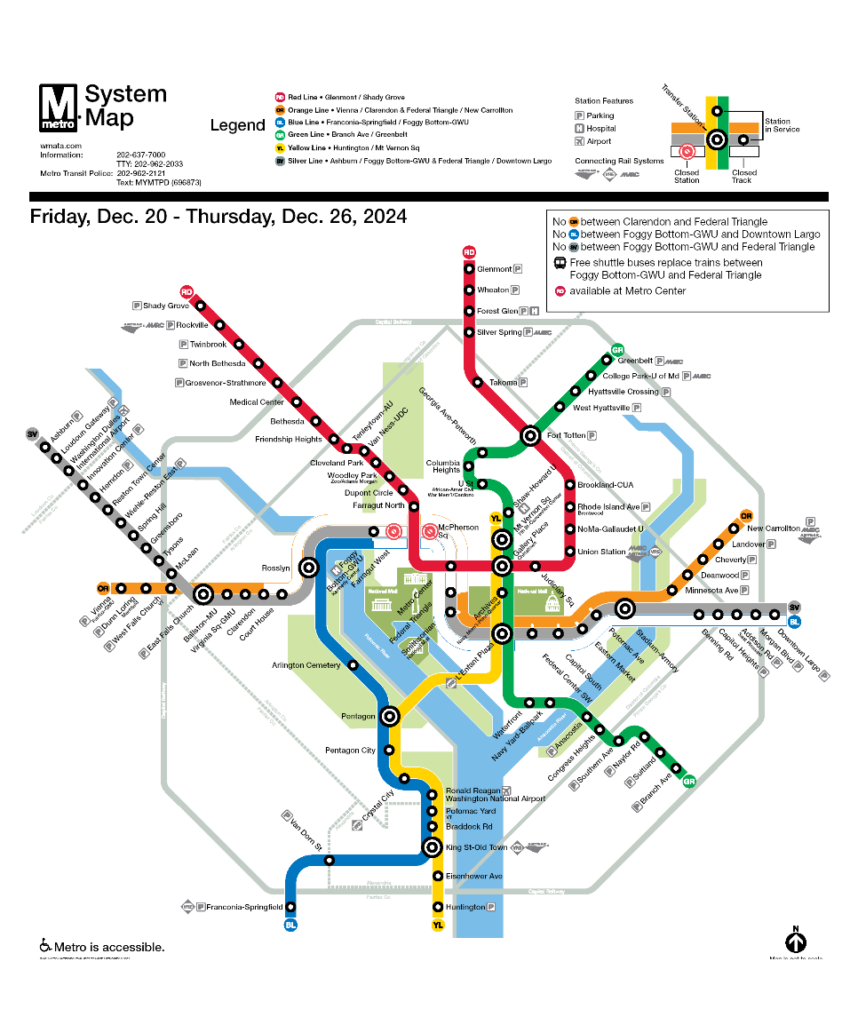

* **System Map Dec 27-30**

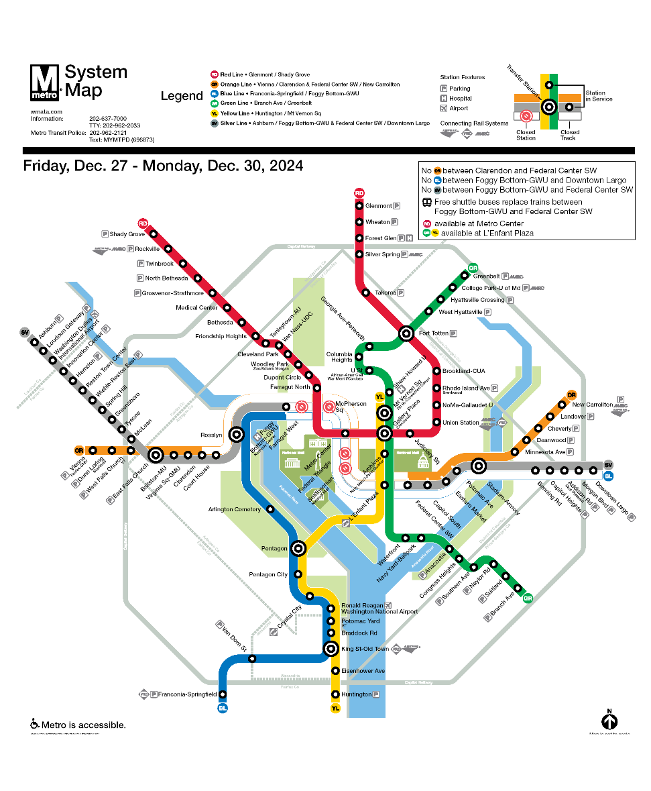

**Shuttle Bus Maps**

* **Shuttle bus map Dec 20-26**

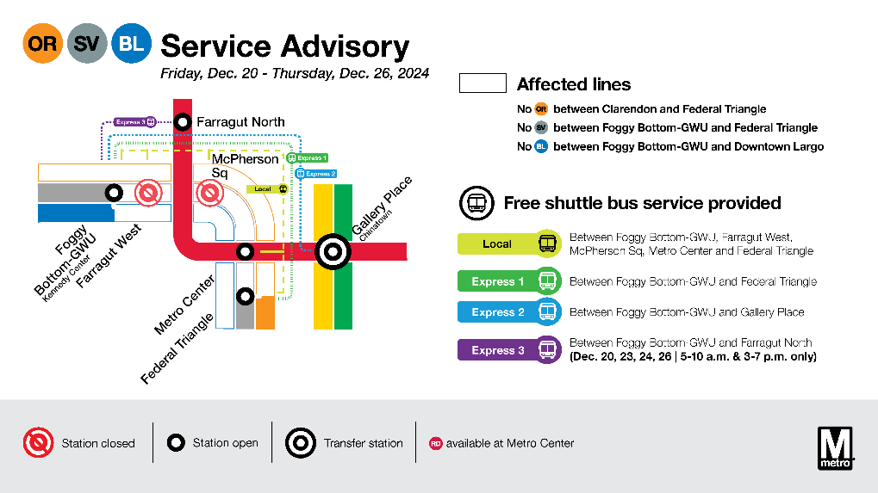

* **Shuttle bus map Dec 27-30**

